/1438هـ
الخطة الإستيراتيجية لكلية الطب للفترة 1434 – 1439 هـ
وحدة التطوير والجودة

كلية الطب
المملكة العربية السعودية - وزارة التعليم العالى
introduction
Planning is the development of progressive steps to reach the future vision based on analysis of the present and future expectations and trends to achieve the desired objectives and identify the appropriate methods and means to achieve these goals efficiently and effectively according to priorities and a specific timetable and precise identification of responsibilities. The strategic planning of institutions of higher education is linked to the administrative activity carried out by senior management in the institution and to analyzing the gap between the resources and possibilities of the institution and the opportunities available in the surrounding environment in order to bridge this gap and achieve the appropriate and strategic alignment. It should be noted that strategic planning is not a strategy or a strategic plan but an activity exercised by senior management in the institution to achieve the mission of the institution.
And the management of the Faculty of Medicine, Najran University, believing that strategic planning - which provides the general framework for the most detailed planning in the different administrative levels of the operational decisions - was taken as a basis for the development of a long-term strategic plan that includes the future vision of the college and the mission it seeks to achieve. The light of this message, as well as taken as a basis for all activities in the college which is in education, scientific research and community participation.
If the world today is characterized by rapid and sharp changes in the external environment, it is strategic planning that helps management to understand these changes and to monitor opportunities and threats related to college activity and outcomes. And helps to know the future vision in the long term, hence the strategic planning of the Faculty of Medicine University of Najran is a necessity of continuity and survival and not a path of luxury.

About the College
The Faculty of Medicine is considered one of the first colleges to be approved and started to study in the university, both boys and girls. This decision was based on a study of the urgent need for this college. The study started in boys in the academic year 1430-1431 AH and in girls in the following year 1431-1432 AH.

Study System:
The study of the academic year on the annual system, and the academic year consists of two semesters.
The study consists of six years of preparatory school, followed by five years of study and a year of training (12 months). The college follows the quarterly system of study (twelve levels) and the study is in English.
The duration of the academic level is a "study" class. The class time is 18 weeks, including weeks of study and tests, taking into consideration that the study should not be less than 15 weeks.
There are also several stages of study, which include a number of classes as follows:
1. Preparatory year (which is administratively not affiliated with the college).
2. The first stage: the third and fourth level.
3. Phase II: Level V to VIII (Pre-Clinical Phase).
4. The third stage: the ninth to twelfth level (clinical stage).
5. The fourth and final stage: the year of excellence.
In the Faculty of Medicine for Boys there are two types of courses, a longitudinal decision and an integrative course. The longitudinal course is studied along the length of the course in parallel with other longitudinal courses. The integrative course is taught in a separate time period of the semester. Integrative courses are taught sequentially, unlike the longitudinal courses taught in parallel. The duration of the course is 2 to 8 weeks.
Each course has a number, code, name, and description of its vocabulary in terms of content and level of other courses, and a special file maintained by the department for the purpose of monitoring, evaluation and development.

Evolution of the number of students in the faculty:

First, the development of the number of students in the Faculty of Medicine Benin:
The College started with the boys department in the academic year 1430-1431H with 22 students, followed by the following year (1431-1432H). The number of students reached 18, and the number of students at all levels started from 40 students. The academic year 1432 - 1433 H after the enrollment of 23 students in this year, and the number reached the current year (1433 - 1434 e) to 94 students after the enrollment of 31 students this year.

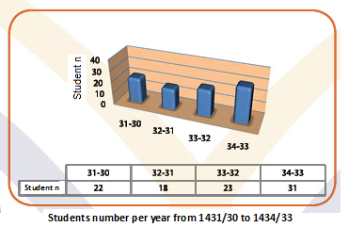

A diagram showing the numbers of students enrolled in the Faculty of Medicine for boys for each academic year starting from 1430-1431 H until the current year 1433 - 1434 e
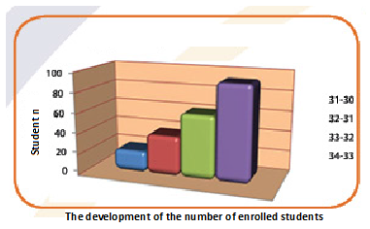

A chart showing the development of the number of students enrolled in the Faculty of Medicine for Boys since its opening in 1430-1431 H until the current year 1433 - 1434 e.

Second, the development of female students in the Faculty of Medicine Girls:
The College started with the division of girls in the academic year 1431-1432 AH with 9 female students, followed by the following year (1432-1433H). The enrollment of 9 female students also became the number of female students in the college in this year at all levels. The number of the current year (1433 - 1434 e) reached 28 students after the enrollment of 10 female students this year.

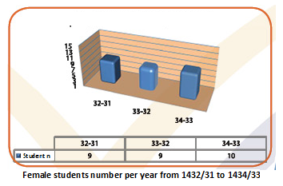

Diagram showing the numbers of female students enrolled in the Faculty of Medicine divided girls for each university year since its opening in 1431-1432 until the current year 1433 - 1434 e.

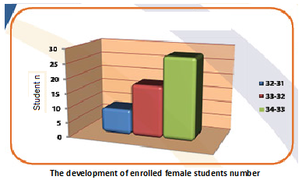

A chart showing the development of the female students enrolled in the Faculty of Medicine Girls since its opening in 1431-1432 H until the current year 1433 - 1434 e.

Evolution of faculty members:
First, the development of the numbers of faculty members and assistants in the College Boys:
The College started in the academic year 1430-1431H with 19 members, and in the following year (1431-1432 AH) the number of members rose to 8 members to become 27 members, and in 1432 - 1433H became the number 45 with an increase of 18 members, and then reduced the number this year (1433 - 1434 e) to become 44 members after the presence of one faculty member and the departure of two.

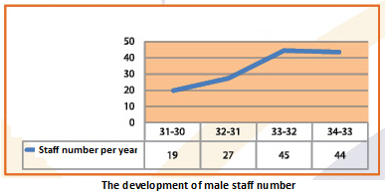

Second, the development of the numbers of faculty members in the faculty Girls:
The College started in the academic year (1431 - 1432H) with 8 female members and then the number of female members increased to 15 in 1432-1433H then

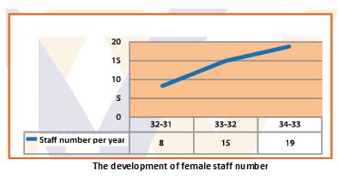

Number of students to faculty members, boys and girls, for male and female students:
First: faculty of Boys
The number of faculty members in the academic year (1433-1434 e) is 44 members and the number of students in the college is 94 students at 2.1: 1 (faculty member for every 2.1 students).
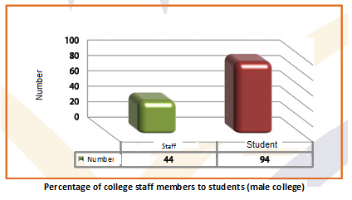
Second: faculty of Girls
The number of faculty members in the academic year (1433-1434 e) is 19 members and the number of female students is 28 (1 faculty member for 1.5 students).
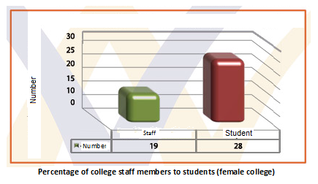
The development of the technical and administrative staff of the college with its boys and girls:
The College started in the academic year 1430-1431H with 25 personnel in administrative and technical cadres. In the following year (1431-1432 AH), the number of administrative and technical staff increased by 12 individuals to 37 individuals. In 1432/1433 AH, number 44 increased by 7 individuals, Then the number reached in the academic year (1433 - 1434) to 53 individuals.
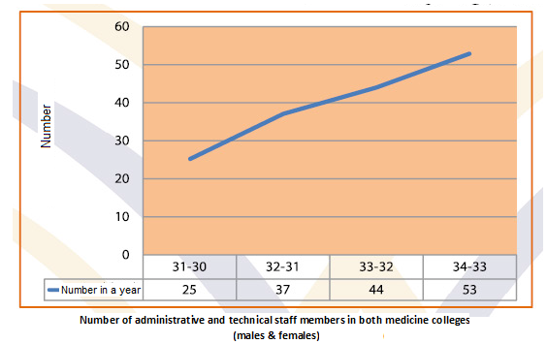

A diagram showing the evolution of the administrative and technical cadres of the Faculty of Medicine in its villages (boys and girls) since its opening in 1430-1431 H until the academic year 1433 - 1434H.

Previous studies
- Local universities
College of Medicine, King Saud University
Vision:
To lead the way in medical education and health services. And to have a clear footprint in promoting health in the Saudi society, and provide outstanding additions to medical science worldwide.
The letter:
We teach and train health practitioners in a creative learning environment.
We explore new perspectives in scientific research and produce important scientific contributions to the world.
We provide high quality health services to Saudi society.
We harmonize medical education, scientific research and health care in a comprehensive environment.
Value:
innovation and creativity
Credibility
Superiority
Responsibility
Teamwork
Continuous education

Faculty of Medicine King Abdulaziz University

The letter:
The College of Medicine at King Abdulaziz University is committed to providing high quality educational programs for its students and students in the undergraduate and postgraduate stages, sponsoring research projects, supporting scientific activities and communicating with the community in the Kingdom of Saudi Arabia
Vision:
To be a reference in medical academic excellence in the Middle East

Objectives:
Education field
- Achieve high quality of the educational program for the bachelor's and graduate studies in the field of medicine
- Develop the student's abilities for self-learning, analytical thinking and problem solving
- Graduation of students to practice their duties according to Islamic
regulations and ethics
Research field
- Access and maintain research excellence related to health and disease
- Participate in the writing, translation and dissemination of knowledge in the medical field

Community area
- Disseminating the ideas of preventive medicine in society
- Providing health care services based on scientific evidence at all levels of primary and advanced care
- To spread the culture of community involvement through health education and health services

Faculty of Medicine Umm Al-Qura University:
Vision:
The College should have a leadership role at the local, regional and international level in the field of preparing the workforce in the field of health, and should be a distinguished center for the provision of medical services, and distinguished for the conduct and dissemination of medical scientific research to serve humanity.
The letter:
Prepare doctors who are able to meet the needs and needs of the Saudi community through a medical education program that follows international standards of academic accreditation, builds the motivation and ability to seek to develop themselves through continuing medical education, and enable them to deal with future changes in medical science and health care methods, and can work to advance the advancement of medical science through scientific research.

Value:
The College of Medicine aims to achieve its objectives of graduating a highly qualified doctor in accordance with the principles of the Islamic religion and the values ​​of the Arab society and based on the privacy of the place, it will be able to take responsibility for the care of the hajji of the House of God.
Through its distinguished program, the College has created the necessary behaviors in its graduates to be community-oriented, capable of caring for the community members in health and disease, working on disseminating preventive behaviors and healthy lives of individuals and communities and having the motivation to develop their own abilities.
The College is committed to applying national and international quality standards in its outputs.
The College should have a positive and tangible role in the advancement of medical sciences through conducting outstanding researches to solve health problems in Makkah society and its visitors from all over the world.

Faculty of Medicine, University of Taiba
Vision:
Saudi Medical College aspires to be a leader and distinct in modern medical education that combines tradition and modernity, and is looking to be a radiation research center in medical science to upgrade health services regionally and globally.
The letter:
Create an interactive, student-centered medical education environment of global quality.
Create a stimulating learning environment for creativity.
Support the integrative relationship between medical education, scientific research and health care.
Participate in the provision of health care to the Saudi community through the preparation of qualified Saudi doctors and through the university hospital.
Maintaining the morals of a Muslim physician, medical professional and the preservation of social values.
Create a suitable research atmosphere for faculty members and graduate students.
Value:
devotion
honesty
Respect and appreciation
Commitment
Mastery
Creativity
The responsibility
The quality
Teamwork

Faculty of Medicine King Faisal University
Vision:
To become a model for supporting community partnership through excellence and international recognition in the fields of medical education, medical research and health care.
The letter:
We are committed to promoting advanced standards in the areas of medical education, health care, research and community health services.
Value:
Islamic values
Creativity
Leadership
Commitment to lifelong learning
Excellence
Compassion
Responding to the needs of society
Objectives:
Preparing and qualifying generations of qualified doctors equipped with the necessary knowledge and skills necessary to provide the health team working in the Kingdom to meet the requirements of modern times and to meet the challenges of the twenty-first century health efficiently and efficiently.
Expand health education in the region and provide quality health services to the community.
Strengthen scientific research capacity, encourage health research to reduce disease risk, and be vigilant against risk of future diseases.
Focus on CME programs to enhance the capabilities and skills of health market workers.
Submit postgraduate programs in clinical specialties and basic medical sciences to prepare specialists to meet the needs of the Kingdom.
Leadership and reference in health education.
Adopting comprehensive quality systems and standards in education, learning, training and development, and in providing health services for the advancement of the general health situation in the country.

Regional Universities
Faculty of Medicine Ain Shams University
Vision:
The Faculty of Medicine aspires to be the first in the Middle East to graduate doctors with competitive abilities and to lead the reform in medical education.
The letter:
The Faculty of Medicine at Ain Shams University is preparing a graduate of a highly skilled trainer at the local and regional level, capable of teaching, learning and lifelong training and is committed to the standards of medical service and professional ethics. The College seeks to continuously develop programs and courses and support scientific research, To serve the needs of society and environmental development.
Suez Canal University
Vision:
To become a standard model for Egyptian medical education institutions, offering a high quality educational program for the preparation of competent doctors able to compete at the national, regional and international level and be attractive to students of other countries.
The letter:
College Message:
To provide an educational system designed to prepare qualified doctors who are able to meet the health needs of the individual and society in a satisfactory manner, whether at the national level or the global level and be able to continue to learn and research throughout their lives.
Research Mission:
To adopt scientific research soundly systematic and morally committed, both undergraduate and postgraduate students - that the scientific research to address the problems of the community of priority in a manner consistent with the progress of scientific world.
College Mission in Health Services:
To contribute to the provision of safe, high quality health care at an appropriate economic cost at all levels of health care, whether level I, II or III.
College Message for Community Participation:
To communicate with the community leaders and officials in charge of health care to identify the needs and problems of the society and contribute to meeting these needs and addressing these problems.

International Universities
Harvard Medical School

Vision:
Provide a safe, functional, and comfortable environment conducive to learning, working, and conducting research through Professionalism, Excellence, and Teamwork

Mission:
To create and nurture a diverse community of the best people committed to leadership in alleviating human suffering caused by disease.

Values:
Safety: Provide and support a safe and reliable climate
Professionalism: Honest and accountable people who demonstrate a natural affinity to being flexible, proactive, trustworthy, willing to stop or change, and be technically inquisitive, all with the utmost integrity
Excellence: World class leaders fostering a culture of continuous improvement, with innovative, effective, responsive and timely solutions, affording clear direction derived from proactive, well organized planning
Teamwork: Placing group success, and the respect of all individuals ahead of personal achievement while insisting on clear, widespread communications governed by customer focus
Environmental Stewardship: Embrace an environmentally conscious approach to all activities with a mindset of sustainability

Stanford school of medicine:

Mission:
To be a premier research-intensive medical school that improves health through leadership, diversity, and a collaborative approach to discovery and innovation in patient care, education, and research.

Vision:
Through the pursuit of our mission we will realize the following vision:
A medical school founded on the advancement of knowledge through research and education and recognized as one of the best research-intensive medical schools in the world.
A medical school in which an environment of investigation, discovery, scholarship, and intellectual exchange supports a community of faculty, students, and staff with strong academic leaders in the biomedical sciences.
A medical school in which the common goal of improved health guides patient care, education, and research, thereby fostering the collective pursuit of knowledge and its translation, through education and application, to bettering the human condition.
A School and University each made stronger and, together, greater through close academic and administrative partnerships.

Goals
Become a leader in the movement to reform and rejuvenate the education and career development of biomedical innovators.
Transform the future of biomedical, translational, and clinical research and education by fostering novel collaborative alignments among basic and clinical scientists, clinicians, and educators throughout the University, as well as with public and private partners worldwide.
Earn the public's trust and respect as a premier medical school through outstanding patient care and academic medicine.

Najran university
University vision
Leadership in teaching, learning and community service, and active participation in building a science and knowledge society.

University Message
To provide education and learning to meet the needs of the society and the labor market, and to contribute effectively to sustainable development through applied research, the optimal use of modern technologies and the activation of partnership at the local, regional and global levels.

University Values
Within the framework of the belief of the University of Najran in the values ​​and teachings of the Islamic religion, the University is committed to basic values ​​that are adopted as guiding directives for the conduct and performance of all its employees and academic and administrative units in all activities, procedures and decisions.

These values ​​are:

value | The definition
Leadership | Support and enhance skills and leadership roles at all levels.
Responsibility | Positive interaction towards the university and society from the sense of responsibility.
Secretariat | performance of duties and fulfillment of rights.
Transparency | is clear in all activities, decisions and transactions.
Accountability | takes responsibility for the results of our actions and readiness for clarification.
Justice | is all right.
Respect | for civilized, humane and respectful practices in accordance with Islamic values.
Teamwork | Team work and exchange experiences and knowledge.
Creativity | Create an environment conducive to stimulating creative thinking product in accordance with the teachings of Islam.
Quality | Ensuring quality performance according to local and global standards

Objectives of the University
According to the University's mission, there were strategic determinants and each of the objectives or several strategic objectives:

The first strategic determinant: teaching and learning
The first strategic objective: Access to academic programs to the global level within the framework of Islamic values.
Second Strategic Objective: To prepare highly qualified students for the future.
Third Strategic Objective: Enhancing the efficiency and efficiency of faculty and others.
Second strategic determinant: supportive environment
Fourth Strategic Objective: To promote and invest in university facilities and the use of modern technologies.
Fifth Strategic Objective: Improve learning resources according to standard standards.
Sixth Strategic Objective: Excellence in the services and support of students.
Seventh strategic objective: To develop financial and administrative systems in accordance with the overall quality standards.
The third strategic determinant: graduates and the labor market
Eighth Strategic objective: Securing a promising career for graduates.
Fourth strategic determinant: science and knowledge
Ninth Strategic Objective: Develop the scientific research system to support sustainable development.
Tenth Strategic Objective: Upgrading the postgraduate programs.
Fifth Strategic determinant: Community responsibility
The 11th Strategic Objective: Continuous and effective commitment to serve the community.
Sixth Strategic determinant : Partnership
Twelfth Strategic Objective: Building a system of partnership and cooperation locally, regionally and globally



COLLEGE STRUCTURE

Proposed College Structure

First: The Dean of the College. Director of the Dean's Office
Second: Advisory Committee
Third: College agents and director of administration:
1. Vice Dean for Academic Affairs.
2. Vice-Dean of the College (female section).
3. Vice Dean for Graduate Studies and Scientific Research.
4. Vice Dean for Development and Quality.
5. The director of the college administration: It is followed by:
1. Financial Affairs Department.
2. Department of Administrative Affairs.

Fourth: Scientific Departments in the College: -
1. Department of Anatomy.
2. Member Functions Section.
3. Department of Biochemistry.
4. Department of microorganisms.
5. Department of Pathology.
6. Department of Family and Community Medicine.
7. Department of Obstetrics and Gynecology.
8. Department of Pediatrics.
9. Department of Surgery.
10. Department of Internal Medicine.

Fifth: Committees and Units of the College:
1. Scientific Research Unit and Community Service.
2. Postgraduate Unit.
3. Development and Quality Unit.
A. Institutional Focus Committee.
B. Education and Learning Axis Committee.
C. Focus Committee to support students' education.
D. Infrastructure Support Hub Committee.
E. Committee on Community Contribution.

4. Medical Education Committee.
5. Office of Excellence and Alumni Affairs.
6. Information Technology Unit.
7. Continuing Education Unit.
8. Training and Development Unit.
9. Registration and Academic Guidance Unit

According to the following scheme

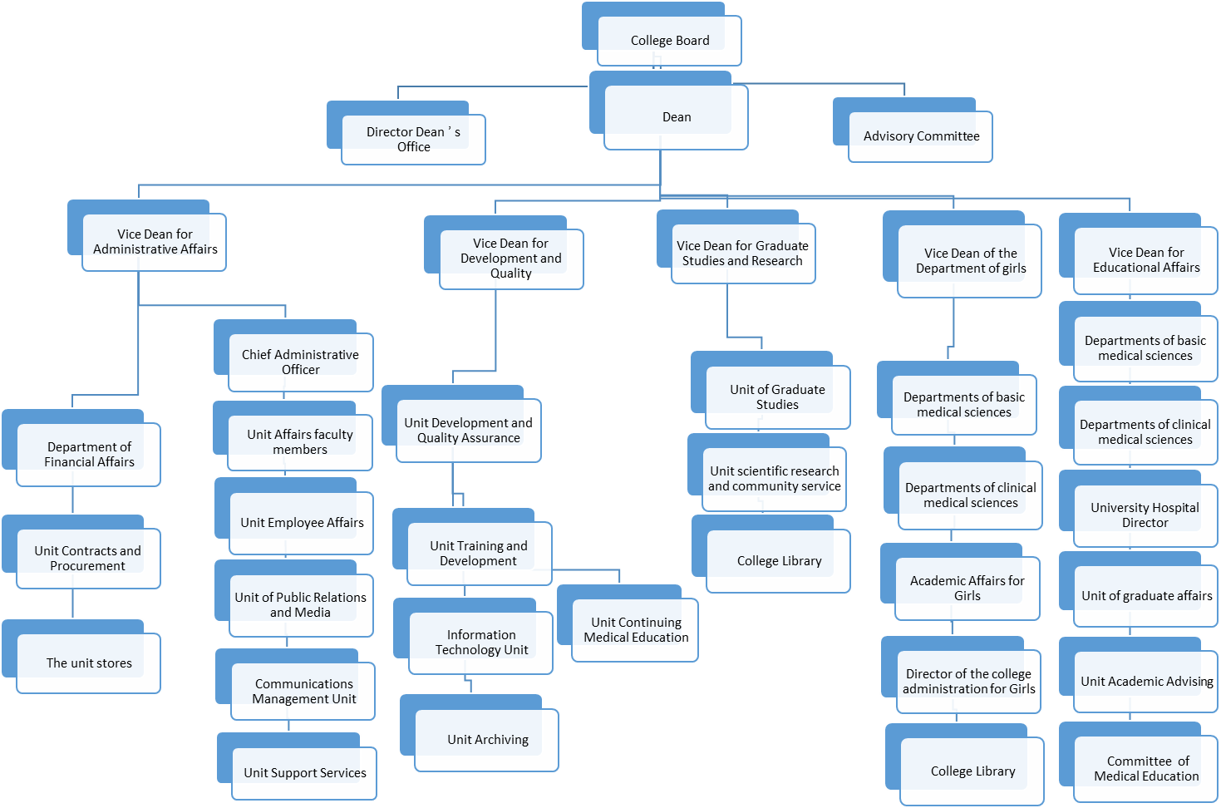

Type of Institution:
College of Medicine - Najran University is one of the governmental higher education institutions in Saudi Arabia

Nature and types of educational programs:
The College offers a Bachelor of Medicine and Surgery program

Jobs that program graduates are preparing for:
Physician

Dean of the College:
Dr.. Jobran Mari Jobran Al Qahtani

The conceptual and methodological framework of the Strategic Plan

1. Spread the culture of planning as an input to development

2 - Spreading the culture of quality, accreditation and excellence in performance to improve and develop the administrative and educational system

3. Building plans for self-study of the college, identifying strengths, weaknesses, opportunities and external threats

4. Establish clear benchmarks for performance and benchmarking between actual performance and quality standards to identify improvement needs to bridge the gap.

5. Develop programs and develop plans with future visions to improve the quality of all processes and activities in the faculty

6. Ensuring that all employees at all levels enjoy the right to participate and be responsible

7. Continuing follow-up to the implementation of the Strategic Plan and operational plans for development and improvement

8. Periodic evaluation through an internal and external group

9. Disseminate follow-up and evaluation results

Strategic Planning Process

1. Environment analysis:
Quadratic analysis SWOT

The internal environment |  | The external environment
Strengths points | Weaknesses | Opportunities | Threats

2. Strategy formulation:
Prepare the vision and then review it.

Prepare the message and then review it

Setting the strategic objectives of the program.

3. Implementation of the Strategy:
Software

Executive Plans

Activities and procedures

4. Follow- up and evaluation of the plan
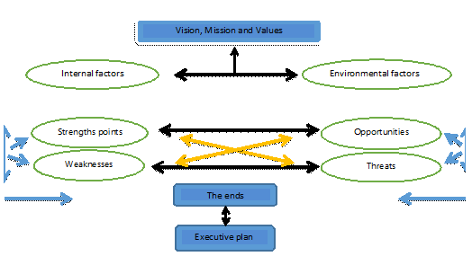

Steps to prepare the strategic plan
Forming the “Strategic Planning Team". | - 1
Organizing a workshop to prepare the strategic plan. | - 2
Diagnosis of the current state of the college through environmental analysis (analysis of strengths, weaknesses, opportunities and threats). | - 3
Formulate the vision and conduct a survey………... | - 5
Formulate the college mission that ensure the expression of vision and represents the dimensions of the appropriate environment and mechanisms for the transition from the current situation to the target situation. | - 6
Determine the strategic objectives that the College wants to achieve through frequent meetings of the Planning Committee. | - 7
Maintaining the vision, mission and strategic objectives within the college (at the administrative and academic levels) and outside (for partners) to benefit from feedback | - 8
Adopting the vision, mission and strategic objectives from the Board / Dean of the College. | - 9
Identify appropriate operational plans that will contribute to achieving the strategic objectives. | - 10
Preparing the programs that will be implemented within the framework of the strategic plan and specifying the stages of time and the authority responsible for implementation | - 11
Building operational action plans. | - 12
Prepare a matrix of performance indicators that will be used to measure the performance of the college. | - 13
Prepare and discuss the draft plan with the Strategic Planning Committee. | - 14
Submit the plan for adoption by the College Council as final. | - 15
Announced and disseminated and made available to the college for employees. | - 16
Start implementing the plan. | - 17
Feedback for all previous steps. | - 18

INCLUDEPICTURE "https://encrypted-tbn0.gstatic.com/images?q=tbn:ANd9GcS_L7Sb8UZGiBk869DJucxlvehWPIe18Jw-MU8GfkkFFmF1PoAXFA" \* MERGEFORMATINET INCLUDEPICTURE "https://encrypted-tbn0.gstatic.com/images?q=tbn:ANd9GcS_L7Sb8UZGiBk869DJucxlvehWPIe18Jw-MU8GfkkFFmF1PoAXFA" \* MERGEFORMATINET 
Stakeholder Parties
Meeting the needs and expectations of stakeholders is to determine the effectiveness and reality of the plan for quality assurance, excellence of the education and research service, and the extent of the college contributions to the community and environment service. Parties include stakeholders:
- College Management
- Members of the teaching staff, the assistant staff, administrators and staff
- Students – Parents
- Health & Medical Sector in Najran
- Najran Health Affairs Directorate
- Ministry of Health hospitals
- Primary health care centers in the region
- Private medical sector
- Armed Forces Hospital

The competitive status of the college at the community level
The Faculty of Medicine at Najran University has a distinguished competitive position as it is one of the first medical colleges in the southern region of the Kingdom, which provides the local labor market graduates with a high level of efficiency, enabling graduates to obtain good job opportunities in hospitals and health institutions. The college has infrastructure, laboratory equipment, human expertise and faculty members from diverse scientific schools.
The College of Medicine - Najran University is one of the first colleges to establish a quality assurance system. Najran University is working to develop many scientific chairs that contribute to activating the role of the university in local development through conducting studies and researches in the Najran region and providing scientific and advisory support for development plans in addition to setting up various activities and programs that play the role of these chairs in serving the local community.
INCLUDEPICTURE "https://encrypted-tbn3.gstatic.com/images?q=tbn:ANd9GcRy-gy7au-KrtKMIM-GLrAazVLZNnysE9MabqJMTKZ7IXfHOugd" \* MERGEFORMATINET INCLUDEPICTURE "https://encrypted-tbn3.gstatic.com/images?q=tbn:ANd9GcRy-gy7au-KrtKMIM-GLrAazVLZNnysE9MabqJMTKZ7IXfHOugd" \* MERGEFORMATINET 

Vision, Mission and Values

Vision, Mission & Core Values

Vision:

Excellence in medical education and scientific research, and continuous contribution to the advancement of health services in the region and participation in community service.

Mission:

Preparation of qualified medical staff capable of providing distinguished medical services, with excellence in scientific research and multiple partnerships to serve the community and raise the level of health awareness.

Core Values:

Commitment to Islamic values in professional ethics.

Secretariat: performance of duties and fulfillment of rights.

Teamwork: Teamwork and exchange experiences and knowledge.

Respect: to deal with the purity and preservation of dignity according to Islamic values.

Transparency: Full clarity.

Efficiency: Ability to perform work as performed by professionals

Credibility: Matching the verb to the saying.

Responsibility: positive interaction towards the college from the sense of bearing the consequences of it.

Integrity: distance from the question and leave the suspicions.

Creativity: Create an environment conducive to stimulating creative thinking produced according to the teachings of Islam.

Results of the initial self-assessment of the college (1430)

1 | The first criterion  (Vision, mission, goals and objectives) | 1. Lack of vision, message, or objectives for the program. | 1. The program's mission statement reflects the current activities of the program and expresses an independent personality of the program and the Islamic values ​​adopted by the program and linking them to the message of college and university. The message should be brief and expressive and can be used to guide the activities and decisions of the program.  2. Taking the view of the beneficiaries at all stages of preparing the message.  3. Setting up a mechanism to review the message as well as change the message if any internal or external variables are found.  4. Setting goals that reflect what the program is looking for and at the same time can be achieved in the near future.  5. Setting objectives that the program wishes to achieve in the current period.  6. Approving the message, goals and objectives.
2 | Standard 2 (Program Management) | 1. There is no feedback on the performance of faculty members working in the program.  2. The relations of authority and mandates in some jurisdictions are unclear.  3. There is no strategic plan for the program.  4. Performance quality is not measured and feedback is provided to those concerned.  5. There is no code of ethics of the profession stems from the teachings of Islam and is committed by all the program participants.  6. Lack of familiarity with the policies and regulations of the program.  7. There is no mechanism to evaluate the policies and regulations of the program and to develop reports and plans to improve or activate them more efficiently. | 1. Develop a strategic plan for the program.  2. To measure the quality of the performance of faculty members and to develop a mechanism to provide feedback in a timely manner, and to use the results in development plans.  3. Clarification of the power relations and mandates in some specialties of the program members.  4. The establishment of a charter for the ethics of the profession stems from the teachings of Islamic religion committed by the participants of the program.  5. Develop a mechanism to evaluate the policies and regulations of the program and to develop reports and plans to improve or activate them more efficiently.
3 | Standard 3 (Program Quality Assurance Department) | 1. There is no mechanism to encourage creativity and innovation at all levels in the program.  2. There is no mechanism to evaluate the quality of the performance of the officials of the program followed by feedback and plans for development and improvement.  3. There are no internal quality systems to follow the educational aspects and activities of the program.  4. The need to set academic standards with the need to use external academic reference standards.  5. There are no internal quality systems to follow the educational and research aspects and activities of the program.  6 - The need to use clear indicators to measure the quality of performance followed by feedback and plans for improvement and development.  7 - The need to use clear indicators to measure the quality of performance followed by feedback and plans for improvement and development.  8. There is no external review system for the program.  9. There is no mechanism to measure the extent and quality of achieving the objectives of the program. | 1. Develop an internal quality review system to follow up the educational aspects and activities of the program.  2. Develop a mechanism to use clear indicators to measure the quality of performance followed by feedback and plans for improvement and development.  3. Setting academic standards for the program with the need to use external academic reference standards.  4. Develop a system for external review of the program and decisions.  5. Develop a mechanism to measure the extent and quality of achieving the objectives of the program.
4 | Standard 4 (Education and Learning): | 1. The need to set academic standards for the program with the need to use external academic reference standards.  2. There are no development plans for the development of the program and decisions.  3. There is no committee to develop curriculum and training in the program.  4. There are no internal or external systems to evaluate and review the quality of the program and courses.  5. There is no mechanism to measure the extent and quality of achieving the objectives of the educational objectives of the courses.  6. There is no mechanism or study that determines the appropriate teaching strategies to achieve the educational outcomes targeted to the program.  7. There is no mechanism or study that determines the appropriate methods of evaluating students for the different types of educational outputs targeted to the program and courses.  8. There are no programs to develop the skills of students in English  9. The need to activate academic guidance for students within the program.  10. The need to establish a mechanism to assess the quality and extent of the benefit of educational assistance provided to students.  11. The need to provide feedback to students about their performance.  12. There are no programs within the program for new students.  13. There is no description and reports of the courses.  14. There is no mechanism or study that determines the suitability of teaching strategies to achieve the targeted educational outcomes of the program and decisions.  15. There is no mechanism or study that determines the appropriate methods of evaluating students for different types of educational outcomes targeted to the program and courses.  16. There is no mechanism or study that determines the appropriateness of books and references to achieve the educational objectives of the courses.  17. There are no programs to prepare new faculty members for teaching and learning strategies within the program.  18. There is no mechanism or policy to develop learning and learning strategies within the program.  19. There is no policy or mechanism to encourage faculty members to participate in scientific activities related to their specialties.  20. It is necessary to develop a plan for the field training of students in different stages of the program.  21. Conduct a study to determine the appropriate field training to achieve the intended educational outcomes. | 1. Develop a mechanism to measure the extent and quality of achieving the objectives of the program.  2. Develop a mechanism or work study that determines the suitability of teaching strategies to achieve the targeted educational outcomes of the program and decisions.  3. Develop a mechanism or work study that determines the appropriate methods of assessment of students for different types of educational outputs targeted to the program and decisions.  4. Develop a mechanism or study work to determine the suitability of books and references to achieve the educational objectives of the courses.  5. Design programs to prepare faculty and new staff for the teaching and learning strategies within the program.  6. Develop a plan for the field training of students in different stages of the program.  7. Conduct a study to determine the extent to which field training is appropriate to achieve the intended educational outcomes.  8. Forming a committee to develop curricula, courses and training.
5 | Standard 5 (Student Affairs and Support Services): | 1. There is no measurement of student satisfaction in the program about the quality of registration and acceptance processes, and raising the results for those interested.  2. There is no mechanism for the program to follow the progress of students during their study of the program and the work of statistics and reports necessary and therefore difficult to follow students defaulting and solve their problems in a timely manner, as well as difficult to prepare plans to develop the program.  3. There is no mechanism in the program to protect students from being subjected to punishment or injustice in the case of grievances or complaints.  4. Extension services within the program require a clear policy.  5. There is no mechanism or policy approved within the program to follow the students defaulting and solve their problems. | 1. Measuring students' satisfaction with the quality of registration and admission processes.  2. Develop a clear policy for extension services within the program.  3. Develop a mechanism for the program to follow the progress of students during their study of the program and the work of statistics and reports necessary to be able to follow students defaulting and solve their problems in a timely manner, as well as the preparation of plans to develop the program.  4. Develop a program mechanism to protect students from being subjected to punishment or injustice in case of grievances or complaints
 | Standard 6 (Learning Resources) | 1. There is no planning in terms of strengthening learning resources.  2. There is no measurement for the satisfaction of faculty members and students about the sources of education and necessary services.  3. There is no calendar and improvement plans related to the sources of education and services provided.  4. There is no library for the program.  5. There is no guidance for students to use the central library.  6. Do not offer programs to train students to use the central library.  7. Conduct a study to determine the adequacy of resources and facilities for the needs of the program. | 1. Follow the planning with regard to strengthening the sources of learning.  2. The work of a mechanism to measure the satisfaction of faculty members and students on the sources of education and necessary services.  3. Making a system for evaluating and developing plans to improve the sources of education and services provided.  4. Create a special library for the program.  5. Organizing service delivery times in the Central Library according to the students' time.  6. Design programs to train students to use the central library.
 | Standard 7 (Facilities and Equipment) | 1. There is no plan for the program to determine the needs of the program for facilities and equipment according to special specifications that enable the program to carry out its activities.  2. There is no mechanism for the rehabilitation of facilities and devices for those with special needs.  3. There is no mechanism to evaluate facilities and equipment scientifically and technically and to know the extent to which they conform to the quality standards recognized in the medical community.  4. Establish a mechanism to measure the level of satisfaction of faculty members and program staff about the quality and suitability of facilities and equipment and use the results in developing plans to develop and improve facilities and equipment.  5. No facilities for extra-curricular activities and services.  6. There is no mechanism to regulate the use of facilities and equipment and increase the efficiency of use.  7. There is no approved plan for periodic maintenance of facilities and devices  8. There is no study to determine the suitability of numbers and types of computers for both the number of faculty members and the number of students.  9. There is no program to train faculty members and students in modern information technology. | 1. Develop a plan for the program to determine the needs of the program for facilities and equipment according to special specifications that enable the program to exercise its activities.  2. Establish a mechanism for the rehabilitation of facilities and devices for those with special needs.  3. Setting up a mechanism to evaluate facilities and equipment scientifically and technically and to know the extent to which they conform to the recognized quality standards in the medical community.  4. Establish a mechanism to measure the level of satisfaction of faculty members and program staff about the quality and suitability of facilities and equipment and use the results in developing plans to develop and improve facilities and equipment.  5. Establish facilities for extra-curricular activities and services.  6. Establish a mechanism to regulate the use of facilities and equipment and increase the efficiency of use.  7. Establish an approved plan for periodic maintenance of facilities and equipment.  8. Conducting a study to determine the suitability of numbers and types of computers for both the number of faculty members and the number of students.  9. Design a program to train faculty and students in modern information technology.
 | Standard 8 (Financial Planning and Management) | 1. There is no actual participation in the financial planning and budgeting of the program. | 1. Establish a mechanism for effective participation in financial planning and budgeting for the program.
 | Standard 9 (Recruitment) | 1. No induction programs are offered for new faculty members.  2. There are no studies on the qualifications and the number of faculty members to achieve the targeted educational results and objectives of the program.  3. There is no clear mechanism for assessing the performance of faculty members.  4. There is no mechanism to benefit from performance evaluation in development and improvement plans.  5. Non-participation of faculty members in scientific activities related to their specialties. | 1. Provide training programs for new faculty members.  2. Conduct studies on the qualifications and number of faculty members to achieve the targeted educational outcomes and objectives of the program.  3. Develop a clear mechanism to evaluate the performance of faculty members.  4. Develop a mechanism to benefit from performance evaluation in development and improvement plans.  5. Establish a mechanism to encourage the participation of faculty members in scientific activities related to their specialties.
 | Standard 10 (Scientific Research) | 1. There is no research plan for the college.  2. The program does not follow up and evaluate the implementation of the scientific research plan.  3. The program does not evaluate the performance of the faculty member in relation to scientific research.  4. Non-participation of faculty members in scientific activities related to their specialties.  5. There is no mechanism to encourage scientific cooperation and joint research with scientific centers and similar programs in other universities. | 1. Develop a research plan for the college.  2. Work on the participation of faculty members in scientific activities related to their specialties.  3. Develop a mechanism to evaluate the performance of the faculty member in relation to scientific research.  4. Establish a mechanism to encourage scientific cooperation and joint research with scientific centers and similar programs in other universities.
 | Standard 11 (Relations with the Community) | 1. There is no approved program for community service.  2. Satisfaction with the community services provided is not measured.  3. There is no plan and mechanisms to implement the community service is renewed annually and measure the level of satisfaction of beneficiaries. | 1. Establish an approved program for the community service program.  2. Measuring satisfaction with community services provided.  3. Develop a plan and mechanisms to implement the community service is renewed annually.

SWOT ANALYSES
Analysis of the internal environment:
SWOT analysis of the internal environment of the college:
strength point | Weaknesses
- Responsible and ambitious management, administrative organization and follow-up work within the college.  - Diversity in faculty members from different universities and countries.  - Conducting training courses, conferences and workshops for faculty members and assistants.  The College has its own website on the Internet  - The vision and mission of the College of Medicine was formulated in a clear and comprehensive manner.  - The presence of a number of modern devices in laboratories.  - Share students' decision-making by exploring their views.  - To encourage the College administration to continuously develop and improve all processes and support the application of quality and accreditation mechanisms.  - The senior management is keen to improve the quality assurance system in the college.  - There is an academic guidance unit.  - The existence of a code of ethics  - Student participation in activities  - The existence of academic standards for the college  - There is a description of the program and the courses offered by the college  - Suitable for lecture halls and classrooms with student numbers.  - The ratio of faculty and teaching staff to students is consistent with reference rates.  - Fully aligned by senior management to improve the quality assurance system in college. | - The lack of adequate rooms for the provision of offices dedicated to faculty members for each department.  - Some plants lack important chemicals and equipment, with no mechanism to bring the solutions and tools consumed in laboratories.  - Shortage in the numbers and specialties of faculty members in the faculty.  - In some decisions.  - Lack of functional characterization to determine the duties of each faculty member.  - Low salaries of teaching staff and lack of material incentives.  - The lack of continuous maintenance of lecture halls or the presence of non-functioning equipment and the lack of the required tools for lectures in the halls.  - The slow provision of budgets for scientific research and activities.  - Lack of suitable transportation for students in college.  - Weak language level in students and lack of competitive spirit among them.  - Lack of experience of some faculty members in university teaching (they are not university cadres in their countries of origin).  - The weakness of the process of academic guidance within the college.  - There is no library at the college.  - Lack of cooperation between the college and other colleges inside and outside the Kingdom.  - Lack of a declared strategy to activate community partnership.  - Lack of approved scientific research plan.  - Not to seriously consider the activation of the preparatory year especially for practical colleges, especially the Faculty of Medicine.  - Lack of sufficient administrative staff to carry out administrative work.  - There are no graduate programs at the college.  - Lack of agency for girls.  - There is no guide for students to introduce the college's systems and activities.  - There is no computer lab for students at the college.  - Weak reliance on e-learning.  - Non-completion of main and subsidiary specialties of faculty members and faculty members.  - Lack of reduced meals for students and students.

Analysis of the external environment:
Analyzing the university environment and showing the development opportunities available from the university to the college
The electronic library of Najran University:
Opportunities:
The Deanship of Library Affairs includes a library index, databases, a digital library, a database for scientific research.
There is a link on the university's website for student electronic services: it is accessed through the university number and civil registration number of the student http://stu.nu.edu.sa/form/login.aspx: As the university is emerging and continues to establish its quality systems, it has developed a questionnaire to evaluate student services on the website.
Threats:
Limited advertising of these activities.
The Central Library of Najran University:
Opportunities:
The total number of the university's holdings of Arabic and foreign books and some other information vessels (40474) were volumes representing (12214) titles distributed among the various university libraries.
The total number of volumes of books, references and other information vessels that were secured during the academic year 1430/1431 H (122,951) of Arab and foreign holdings.
The university provides loan services to students, faculty members and other students who wish to borrow from university employees, students or other groups of society.
Threats:
Limited advertising of these activities.
There is no reduced photography service in the library to photocopy books and references.

University Agency for Development and Quality:
Opportunities:
1- The presence of the Deanship of Development and Quality, which ensures the implementation of quality standards for the various academic programs at the university and contribute to the formulation of the objectives of these programs and verification of their implementation.
2 - Attracting experts specialized in quality and academic accreditation to develop strategic plans for the university and its various units and qualify for academic accreditation.
3 - Preparation of a good test guide and glossary of quality terms and the holding of some workshops, lectures and training courses.
4 - Completion of the project of self-evaluation of the first institutional and program of the university and supporting dues and colleges.
5- The existence of a strategic plan for the university.
Skills Development Unit, Deanship of Development and Quality:
Opportunities:
Provide training courses for faculty members, administrators and academic leaders
Threats:
There is no generalization to require members to attend these training courses.

Information and Communication Technology
The University seeks to transform into electronic transactions.
1 - harnessing a program of administrative communication through which to completely eliminate paperwork.
2- Forming the electronic transactions committee to follow up the transition to electronic transactions.
3 - The University has developed servers and networks on the latest specifications.
4 - The University seeks to expand the administrative communication programs in dealing with other government agencies to get rid of paper transactions.
The university has developed academic, administrative and scientific systems that are reliable, reliable and highly accessible through the Internet
Opportunities:
1 - Elimination of paper transactions.
2. Switching to electronic transactions.
3 - the speed of completion of transactions and follow-up decisions taken.
Threats:
The absence of an account for each faculty member on the administrative communication system.
Do not link faculty members to their departments via the communication system.
Failure to arrange the links of the faculty members with the administrative communication system in order to facilitate communication with them.

Scientific research and community service:
Opportunities:
Prince Meshaal's chair, which works to detect endemic diseases in the region in terms of their types, prevalence and incidence rate, and mortality rate.
The study of endemic pathogens, the factors that cause them, and the associated risk factors.
Identify and develop mechanisms for diagnosis of endemic diseases in patients who are suspected or infected.
Threats:
Limited advertising.
Other threats from inside the university:
1. Inadequate preparatory year for health colleges, including the Faculty of Medicine.
2. Spacing in deanships and supporting facilities, and after the university for the city.
Analysis of the external environment

 | Opportunities | Threats
Political and legal powers | The establishment of the National Commission for Academic Accreditation and Accreditation, which ensures the implementation of quality standards and academic accreditation.  Encourage the exchange of experience between universities at the national and global level  Encourage the creation of new educational programs.  The College of Medicine at Najran University is the only one in the region that can have a virtual reference that can be developed in the field of medical services for the region's hospitals.  The Emir of the region to support research projects at the college.  The existence of a list of higher education. | Weakness of the pre-university education system  The existence of some private colleges.  The presence of competing universities close to the region (King Khaled - Jazan)  Lack of a clear top strategy to support field training  After the city of Najran about the large central cities with the difficulties of travel and lack of transportation and reservations.
Economic powers | Increased support for higher education, which positively affects the support provided to the College.  The increasing need to study medical specialties at the local and regional levels.  The increasing demand for female national cadres, which provides employment opportunities for college graduates.  The possibility of expanding disciplines.  Ensure the appointment of a graduate of the Faculty of Medicine. | Poor coordination between the university and employers.  Globalization (and the possibility of the work of any doctor in multiple countries requires multiple experiences).  The salaries are less than those of other universities and the Ministry of Health.
Social powers | Ease of influence in society for its youth.  The establishment of a regional airport in Najran.  The existence of an industrial environment and a business community that opens channels for the development of the research and educational process.  Changing the culture of the surrounding society as the demand for medical and health programs increased  The community's desire to obtain a high level of services has increased.  The culture of the community in Najran and its need for women in medical specialties (providing Saudi national women cadres).  Benefiting from hospitals in the training of students. | Lack of a culture of cooperation between universities and business organizations  The low population density in Najran community, which reduces the proportion of students enrolled in college.  The society's view of the girl's practice of different medical specialties leads to the reluctance of many students to join the faculty.  Few places of entertainment in the area.
Technological powers | The increasing development in the means of communication and the techniques of teaching aids as well as medical techniques  An electronic portal that allows recipients to complete their transactions using the Internet  Communication systems contribute to the completion of work procedures  Very modern databases

The study of the current state of the college and the identification of strengths and weaknesses and study opportunities and threats in the internal and external environment to develop the strategic objectives of the college in the light of the strategic objectives of the University.

Fourthly : Faculty strategic goals
- Continuous development of curricula and the means of medical education.
- Preparation of morally and professionally medical cadres, well qualified and capable of continuous self-learning.
- Development of the scientific research and cooperation with local, regional and global institutions in medical research environment.
- Development of the university hospital to provide excellent health services to community
- Establishing an academic environment attract talented faculty members.
- To obtain accreditation from National Commission for Academic Accreditation & Assessment.

Vision:
Excellence in medical education and efficient contribution in the scientific research to improve the health services and participation in community services.
Mission:
Preparation of qualified medical cadres, able to provide distinct medical services, and contribution in scientific research and multiple partnerships to serve the community and raise the level of the health awareness.

Core values
- Commitment to the Islamic values in medical ethics
- Honestly : well performance to the duties and fulfilling the rights.
- Teamwork: work together for the benefit of one and all.
- Respect: dignity and honor dealing according to the Islamic values.
- Responsibility: positive attitude with well management of actions .
- Transparency: thorough clearness
- Integrity: being above suspicions.
- Credibility : act emphasis words.
- Professionalism : capability to perform professionally.
- Creativity: motivating creative thinking and originative work within the Islamic scoop.

Policies pursued by the College
The College of Medicine adopts the University's policies based on the standards of the National Commission for Evaluation and Academic Accreditation and the Ministry of Higher Education. The University of Najran derives its regulations and regulations from the Higher Education Council and universities regulations and regulations approved by the Council of Ministers on 4/4/1414 H, which includes the following regulations:
- System of Higher Education Council.
- List of studies and tests for the university stage.
- Regulations governing financial affairs in universities.
- Non-Saudis employment list in universities.
- List of scholarships and training for university staff.
- Uniform Regulations for Graduate Studies in Universities.
- Rules governing the affairs of the employees of the University of Saudi Arabia members of the faculty and the like.
- Uniform Regulation for Scientific Research in Universities.
- Regulation of scientific societies in universities.

Polices (General administrative data)
Standards
Specific mandatory controls
Directions
Recommendations / best practices
Measures
Step-by-step instructions

Fifth: The executive plan to achieve the strategic goals of the college

The strategic plan of the College of Medicine at Najran University aims at achieving the strategic objectives of the college in order to achieve the vision of the college based on its mission based on an implementation plan that contains several projects that seek harmony and synchronization with the university strategic plan. And the mission of the university, and includes the strategic plan of the university twelve strategic goals seeking to achieve its vision, and to achieve these goals were put one hundred and twelve projects are distributed as follows:
- The first objective includes eleven executive projects.
- The second objective includes eight operational projects.
- The third objective includes ten operational projects.
- The fourth objective includes eleven executive projects.
- The fifth target includes seven operational projects.
- The sixth objective includes eleven executive projects.
- The Seventh Objective includes eleven executive projects.
- The eighth target includes seven operational projects.
- The ninth objective includes seven operational projects.
- The tenth target includes eight operational projects.
- The eleventh target includes fourteen operational projects.
- The twelfth target includes seven operational projects.

The Executive Plan of the College includes seventeen operational projects to achieve its six strategic objectives that it seeks to achieve its vision, as follows:
- The first objective includes three projects.
- The second objective includes four projects.
- The third objective includes three projects.
- The fourth objective includes two projects.
- The fifth objective includes two projects.
- The sixth objective includes three projects.

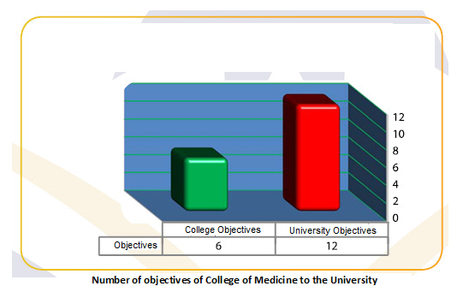

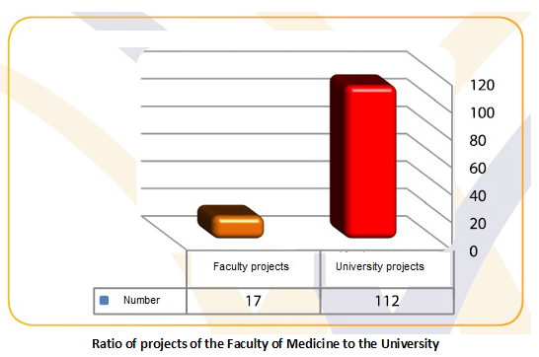

The projects of the executive plan of the college are within the projects of the executive plan of the university as shown in the following table:
N | Number of college projects | Number of university projects
 | 1.1 | 3.1 ,2.1
 | 2.1 | 8.2 ,7.2
 | 3.1 | 1.9
 | 1.2 | 2.8 ,1.8 ,11.6 ,10,6 ,9.6 ,8.6 ,7.6 ,6.6 ,4.6 ,3.6, 2.6 ,1.6, 8.2, 7.2
 | 2.2 | 3.5, 2.5, 1.5, 9.1, 8.1
 | 3.2 | 1.9, 3.3, 2.3, 6.2
 | 4.2 | 1.9, 5.3, 3.3, 2.3
 | 1.3 | 2.9, 1.9
 | 2.3 | 7.9, 4.9, 3.9, 2.9, 1.9
 | 2.7 | 7.11, 6.11, 2.11, 1.11, 4.9, 2.9, 3.4, 4.3
 | 1.4 | 5.6, 10.4, 6.4, 3.4, 2.4, 1.4
 | 3.4 | 7.11, 6.11, 2.11, 1.11, 5.6, 4.6, 6.4, 3.4
 | 1.5 | 3.7, 2.7, 7.4, 8.3, 7.3, 5.3, 4.3
 | 2.5 | 11.7, 10.7, 9.7, 8.7, 4.7, 3.7, 6.4, 3.4, 2.4, 1.4
 | 1.6 | 10.4, 6.4, 3.4, 1.4
 | 2.6 | 11.7,10.7, 9.7, 8.7, 6.7, 5.7, 3.7, 2.7, 1.7, 6.3
 | 3.6 | 1.5

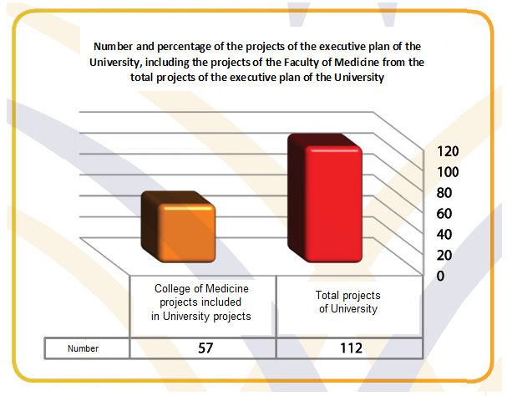

The executive plan to achieve the strategic goals of the college
Strategic goal | Development project to achieve the goal | Administrative activities | Duration | Responsibility |  | Indicators of achievement | Budget
Continuous development of curricula and the means of medical education. | Periodic updating of the program and decisions in light of the adopted standards | Completion of the characterization of courses according to the model of the National Commission for Evaluation and Accreditation and the preparation of quarterly reports.  2.1.1 Adopt global reference standards for the program.  3.1.1 Examining the compatibility of courses, teaching methods and evaluation with the adopted standards.  4.1.1 Review the description of the courses periodically.  5.1.1 Periodic review of the educational program with periodic report.  6.1.1 Study the results of the survey of beneficiaries of the educational program. |  | Development and Quality Unit  Medical Education Committee  Department Coordinators | Follow up of the Strategic Plan under the chairmanship of the Dean of the College | A description of all program decisions  Review the educational programs on a regular basis  Courses that achieve educational objectives | 100 thousand Riyal
 | 1.2 Establish mechanisms for periodic external review of the educational program | External review of the program by specialists periodically.  2.1.2 Survey of external examiners to benefit from feedback in continuous improvement |  | Experts from outside the university |  | Review the tutorial periodically.
 | 1.3 Develop a mechanism to benefit from the results of scientific research in the development of courses | 1.1.3 Work mechanism to benefit from the results of scientific research in the development of courses.  2.1.3 Activate a mechanism to benefit from the results of scientific research in the development of courses.  3.1.3 Honoring researchers whose research results contributed to the development of courses and community service. |  | Scientific Research Committee + Department Coordinators |  | The existence of a mechanism to benefit from the results of scientific research in the development of courses.

Strategic goal | Development project to achieve the goal | Administrative activities | Duration | Responsibility |  | Indicators of achievement | Budget
Preparation of morally and professionally medical cadres, well qualified and capable of continuous self-learning. | Student support | 2- Activate the academic guidance mechanism.  2.1.2 Preparation of a manual for the academic guidance process.  3.1.2 Assess students' satisfaction with academic guidance services.  4.1.2 Locating students' activities within the college.  5.1.2 Organizing meaningful cultural and entertainment competitions |  | Office of Academic Guidance | Follow up of the Strategic Plan under the chairmanship of the Dean of the College | Increased use of students in electronic courses and e-learning | 100 thousand Riyal
 | Develop self-learning capacity and sustainable professional development | 1.2.2 Provide self-learning resources from books, CDs and web sites.  2.2.2 Develop student development programs in self-education.  3.2.2 Measuring the success of e-learning by completing students in electronic courses.  4.2.2 Distribute outstanding models and award prizes to the best lecturers (interactive interactive or interactive lectures).  5.2.2 Making use of the lectures on the College website. |  | Medical Education Committee |  | Increased use of students in electronic courses and e-learning

Strategic goal | Development project to achieve the goal | Administrative activities | Duration | Responsibility |  | Indicators of achievement | Budget
Preparation of morally and professionally medical cadres, well qualified and capable of continuous self-learning. | 3.2 Availability of modern training programs to provide clinical and research skills | 2- Forming a medical training and education unit to develop academic and clinical skills  2.3.2 Develop tasks and responsibilities for unit members.  3.3.2 Prepare follow-up models and evaluate unit performance.  4.3.2 Characterization of field experience according to the model of the National Commission for Academic Accreditation and Assessment.  5.3.2 Work a database of available field training places.  6.3.2 Application of the log book system.  7.3.2 Prepare and approve the Field Experience Assessment Model. |  | Committee for Measurement, Evaluation and Human Development Unit Development and Quality | Follow up of the Strategic Plan under the chairmanship of the Dean of the College | The existence of a unit of medical education with specific tasks and responsibilities  The existence of a database of field training places | 100 thousand Riyal
 | 4.2 Train and develop the skills of faculty members | 2 - Determine the training needs of faculty members and the academic support body.  2.4.2 Prepare a plan for the training of faculty and faculty members.  3.4.2 Work a database of the results of the training plan.  4.4.2 Continuous evaluation of the training plan. |  |  |  | Training 80% of faculty members in the academic and research field

Strategic goal | Development project to achieve the goal | Administrative activities | Duration | Responsibility |  | Indicators of achievement | Budget
Development of the scientific research and cooperation with local, regional and global institutions in medical research environment. | 1.3 Consolidation of credibility and ethics of scientific research. | Establishing a mechanism for the credibility and ethics of scientific research and then activating it  2.1.3 Training researchers at all scientific levels on the ethics of scientific research.  3.1.3 Follow-up of researchers' commitment to ethical standards in conducting the study throughout the research period. |  |  |  | The growing commitment of researchers to the ethics of scientific research
 | 2.3 Promote research projects serving the community and local, regional and global institutions. | 3. Establish an accredited mechanism that encourages the contribution of research projects to the community and helps disseminate their scientific research in international journals.  2.2.3 To prepare a database of research published by researchers at the college and publish it on the website.  3.2.3 Establish a committee to follow up the implementation and implementation of the results and outputs of the research carried out at the college and measure its impact on community service and the development of education. |  |  |  | The existence of a mechanism to benefit from the results of scientific research in the service of the community
 | 3.3 Direct scientific research to study the health problems facing the local community and prepare the appropriate research plan to solve them | 3- Prepare a plan for scientific research directed to health problems in the region.  2.3.3 Adoption of the Scientific Research Plan.  3.3.3 Activate the plan. |  |  |  | The existence of an approved scientific research plan

Strategic goal | Development project to achieve the goal | Administrative activities | Duration | Responsibility |  | Indicators of achievement | Budget
The growing commitment of researchers to the ethics of scientific research | Development of university hospital | 4 Prepare a plan for the development of university hospital.  2.1.4 Provide doctors in all disciplines.  3.1.4 Provide the staff of nurses necessary for the hospital.  4.1.4 Provide the administrative staff necessary for the hospital.  5.1.4 Provision of medical and non-medical equipment for the hospital. |  |  |  | The presence of a modern and comprehensive university hospital.
 | To enhance the contribution of the university hospital to serve the region. | 1.2.4 Full operation of the University Hospital.  2.2.4 Provision of qualified medical personnel.  3.2.4 Effective participation in local and global health events. |  |  |  | The presence of a university hospital at full capacity.

Strategic goal | Development project to achieve the goal | Administrative activities | Duration | Responsibility |  | Indicators of achievement | Budget
 | 1.5 Improve the nature of work for faculty members | 1.1.5 Encourage assignments of faculty members to local, regional and global conferences.  2.1.5 Satisfy the job satisfaction of faculty members and work to solve the difficulties they face.  3.1.5 Minimize the administrative work of faculty members so that they can devote their time to teaching and scientific research. |  |  | Follow up of the Strategic Plan under the chairmanship of the Dean of the College | The growing satisfaction of faculty members
 | 2.5 Improve the internal environment of the college. | 1.2.5 Independence, improvement and development of the financial and administrative system.  2.2.5 Permanent maintenance of the college buildings.  3.2.5 Permanent maintenance and development of classroom equipment.  4.2.5 Permanent maintenance and development of equipment and laboratory |  | The Committee of Resources, Facilities and Equipment in the Development and Quality Unit |  | The growing satisfaction of faculty members

