رؤيتنا:
Unit of Development and Quality
Kingdom of Saudi Arabia
Ministry of Education
Najran University
College of Medicine
Unit of Quality and Development
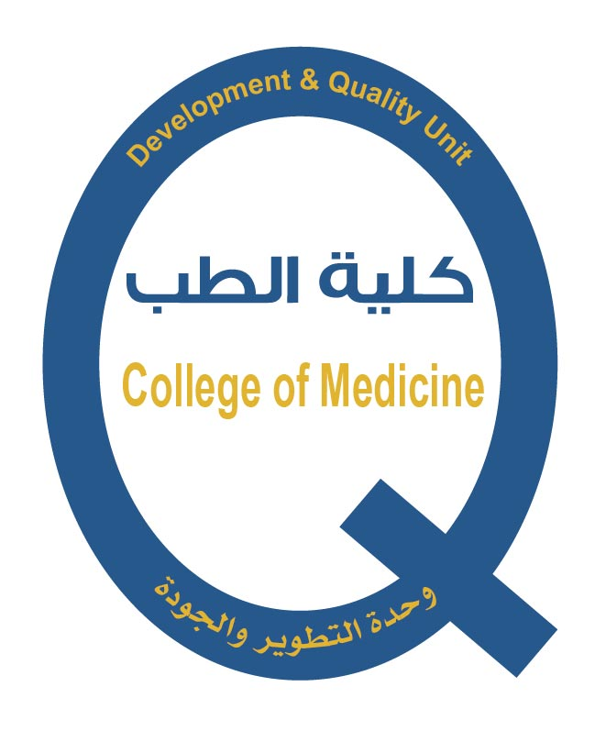

Vision, mission, objectives and goals

Objectives
- Continuous Development of curricula and the means of medical education.
- Preparation of morally and professionally medical cadres, well qualified, and capable of continuous self-learning.
- Development of the scientific research and cooperation with local, regional, and global institutions in medical research environment.
- Contributing to the health education and medical services provided to the community
- Establishing an academic environment attract talented faculty members.

Goals

- The graduation of highly qualified physicians equipped with the spirit of Islamic morality.
- Provision of high quality health and medical services.
- Perform scientific research that services the community.

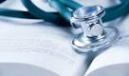

5
6
1

Mission:
Preparation of qualified medical personnel capable of providing distinguished medical services, contributing to scientific research and establishing multiple partnerships to serve the community and raise the level of health awareness.

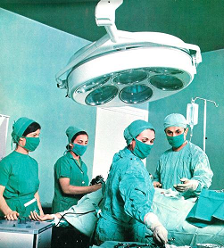

College of Medicine
Vision:
Excellence in medical education and contribution to scientific research to promote health services and participate in community service.



- The college message gives a real picture of the college's founding document, consistent with the nature of the college, and with what is expected of them.
- The college's mission reflects the needs of the community that the college serves.
- The college mission matches the economic and cultural needs of the geographical scope of the community served by the College.

