Course Title: | Graduation Project 1
Course Code: | 571CCN-2
Program: | Bachelor of Science in Computer Networks
Department: | Department of Networks and Communication Engineering
College: | College of Computer Science and Information Systems
Institution: | Najran University

Table of Contents
A. Course Identification 3
6. Mode of Instruction (mark all that apply) 3
B. Course Objectives and Learning Outcomes 3
1. Course Description 3
2. Course Main Objective 3
3. Course Learning Outcomes 3
C. Course Content 4
D. Teaching and Assessment 4
1. Alignment of Course Learning Outcomes with Teaching Strategies and Assessment Methods 4
2. Assessment Tasks for Students 4
E. Student Academic Counseling and Support 5
F. Learning Resources and Facilities 5
1.Learning Resources 5
2. Facilities Required 5
G. Course Quality Evaluation 5
H. Specification Approval Data 6

A. Course Identification

1. Credit hours: |  |  |  | 2 (0,4,0)
2. Course type
a. | University |  |  |  | College |  |  |  | Department |  |  |  | √ | Others
b. |  | Required |  |  |  | √ | Elective
3. Level/year at which this course is offered: |  |  |  |  |  |  |  |  |  |  |  | Level 9
4. Pre-requisites for this course (if any): 452CCN-3

5. Co-requisites for this course (if any):
N/A

6. Mode of Instruction (mark all that apply)
No | Mode of Instruction | Contact Hours | Percentage
1 | Traditional classroom
2 | Blended | 112 | 100%
3 | E-learning
4 | Distance learning
5 | Other

7. Contact Hours (based on academic semester)
No | Activity | Contact Hours
1 | Lecture | 0
2 | Laboratory/Studio | 112
3 | Tutorial
4 | Others (specify)
 | Total

B. Course Objectives and Learning Outcomes

1. Course Description
Graduation project-1 will guide students to conduct a critical background study on their chosen topic. It will assist them on requirements gathering including analysis and synthesizes of gathered data and will aid students to perform feasibility study and functional and non- functional requirements to accumulate problems respective to their topic/environment. It will facilitate them to identify and apply appropriate methods/design to overcome those problems, identify the scope of their project in real world, will support students to critically evaluate proposed design using suitable methods and techniques. Student will develop communication skills through presentation and able to work individually as well as in a team. Students will be guided to maintain ethical issues, documentation formats, use of references and checking plagiarism. And finally students will produce a formal report describing their findings, contributions, and future development/implementation.

2. Course Main Objective
By the end of this course the students are expected to be able to:
- Analyze the problem and develop an initial solution.
- Demonstrate his ability to work independently and as part of a team with colleagues and advisors utilizing good work dynamics.
- Plan effectively for the various project lifecycle activities.
- Conduct an effective literature survey and be able to contrast and critique related work.
- Generate and articulate functional requirements and a preliminary design of the system/project.
- The student will demonstrate a level of effectiveness expected by employers when he produces written documents, delivers oral presentations, and develops, prepares and interprets visual information.
- Produce an academic report.

3. Course Learning Outcomes
CLOs |  | Aligned PLOs
1 | Knowledge and Understanding
1.1 | CLO_1: Classify various computer networks related problems and project live cycle activities such as selecting, planning, analysis, design, implementation, testing, deployment, and maintenance. | K1,k2
1.2
1.3
1...
2 | Skills :
2.1 | CLO_2: Conduct (Survey) an effective background study and be able to contrast and critique related work. | S1
2.2 | CLO_3: Generate functional and non-functional requirements. | S6
2.3 | CLO_4: Analyze the problem and develop an initial solution. | S4
2...
3 | Values:
3.1 | CLO_5: Apply a multi-disciplinary approach to designing the project. | C1,C3
3.2 | CLO_6: Demonstrate his/ her ability to work independently and in a team. | C1
3.3 | CLO_7: Demonstrate his/ her ability to communicate effectively. | C2
3.4 | CLO_8: Prepare report for the project | C2

C. Course Content
No | List of Topics | Contact Hours
1 | Class1: Review of graduation policy | 4
2 | Class 2: Project Proposal (Vision document/feature list) | 4
3 | Class 3: Basics of project management (Tasks, plan, scope) | 4
4 | Class 4: Presentation tools and techniques | 6
5 | Class5: Requirements / Requirements Validation / Functional Specification Document | 24
6 | Class 6: Use case Diagram, Use Case Description / Activity Diagram / Sequence Diagram | 24
7 | Class 7: Data Flow Diagram , System Architecture | 20
8 | Class 8: Database/ ER Diagram | 26
Total |  | 112

D. Teaching and Assessment

1. Alignment of Course Learning Outcomes with Teaching Strategies and Assessment Methods
Code | Course Learning Outcomes | Teaching Strategies | Assessment Methods
1.0 | Knowledge and Understanding
1.1 | Knowledge about various computer networks related problems and project live cycle activities such as selecting, planning, analysis, design, implementation, testing, deployment, and maintenance | Class lectures , working with the team, reading about topic | Presentations, Reports
1.2
…
2.0 | Skills
2.1 | Conduct (Survey) an effective background study and be able to contrast and critique related work. | Class lectures , working with the team, reading about topic | Presentations, Reports
2.2 | Generate functional and non-functional requirements. | Class lectures, working with the team in real case. | Presentations, Reports
2.3 | Analyze the problem and develop an initial solution. | Working with the team in real case. | Presentations, Reports
3.0 | Values
3.1 | Apply a multi-disciplinary approach to designing the project. | Class lectures , working with the team, reading about topic | Presentations, Reports
3.2 | Demonstrate his/ her ability to work independently and in a team. | Distributed work | Presentations, Reports
3.3 | Demonstrate his/ her ability to communicate effectively. | working with the team, | Presentations, Reports
3.4 | Prepare report for the project | Reviews, Feedback | Final Report

2. Assessment Tasks for Students
# | Assessment task* | Week Due | Percentage of Total Assessment Score
1 | Presentation 1(By supervisor) | 9 | 12
2 | Presentation 2(By supervisor) | 12 | 12
3 | Final Presentation (By Examiners) | 14 | 25
4 | Final Report (By Examiners) | 14 | 25
5 | Task assignments (By supervisor) | all | 26
6 | Total |  | 100
*Assessment task (i.e., written test, oral test, oral presentation, group project, essay, etc.)

E. Student Academic Counseling and Support
Arrangements for availability of faculty and teaching staff for individual student consultations and academic advice :
Arrangements for availability of faculty and teaching staff for individual student consultations and academic advice :
Office hours are arranged according to the Timetable.
Graduation projects (1 & 2) are evaluated by the project's supervisor and co-supervisor (40 out of total grade 100) and four internal examiners (60 out of total grade 100).

The supervisor and co-supervisor use the following assessment methods to evaluate the progress of students during the semester (out of 40)
- Task assignment evaluation (out of 24) (Three copies , the first copy is related to the requirements, the second copy is related to the analysis and the last copy is related to the design )
- First Draft Report Evaluation ( out of 8)
- Partial Presentation Evaluation ( out of 8)

The internal examiners use the following assessment methods to evaluate the final Presentation (out of 60)
- Evaluation of the Final Report Documentation (out of 25 common grade for all students in the group)
- Evaluation of the Final Presentation (out of 35 individual grade for each student in the group)

The internal examiners evaluate students' by using rubric that supports reliable grading system.
The main dimensions of the rubrics:
1. Presentation skills
2. Individual Q & A.
3. Project's Documentation.
Rubrics are available upon request.
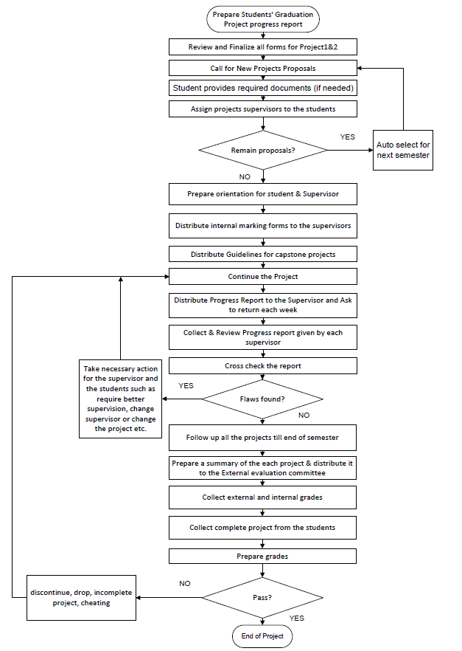

F. Learning Resources and Facilities

1.Learning Resources
Required Textbooks | - Information Technology Project Management , Kathy Schwalbe, 7th edition, 2014.  - Modern System Analysis & Design- Jeffrey Hpffer, Joey George, Joseph Valacich, 6th edition, Pearson  - B.A. Forouzan, Data Communications and Networking, fourth edition, McGraw – Hill  - Electronic Commerce 2010, A Managerial Perspective, Prentice Hall, (latest edition). Efraim Turban, Jae Lee, David King and Michel Chung  - Ethical and Social Issues in the Information Age, Joseph M. Kizza Springer; 4th Edition, 2010  - Harpreet Singh, (Implementing Cisco Networking Solutions: Configure, implement, and manage complex network designs 1st Edition, Kindle Edition), Packt Publishing, 2017.
Essential References Materials | (Journals, Reports, etc.)
Electronic Materials | Web Sites, Facebook, Twitter, etc.
Other Learning Materials | Computer-based programs/CD, professional standards or regulations and software.

2. Facilities Required
Item | Resources
Accommodation  (Classrooms, laboratories, demonstration rooms/labs, etc.) | Project Lab
Technology Resources  (AV, data show, Smart Board, software, etc.) | Soft wares available in the labs’ computers
Other Resources
(Specify, e.g. if specific laboratory equipment is required, list requirements or attach a list)

G. Course Quality Evaluation
Evaluation  Areas/Issues | Evaluators | Evaluation Methods
Effectiveness of teaching and assessment | Students | Questionnaire
Achievement of course learning outcome | Teacher | Presentation 1,2
Quality of learning resources | Faculty & students | Questionnaire
Evaluation areas (e.g., Effectiveness of teaching and assessment, Extent of achievement of course learning outcomes, Quality of learning resources, etc.)
Evaluators (Students, Faculty, Program Leaders, Peer Reviewer, Others (specify)
Assessment Methods (Direct, Indirect)

H. Specification Approval Data
Council / Committee
Reference No.
Date | January 19, 2019

